

**Social Media Overview**

Did you know that in 2021 there were more than 295 million users of social networks in the USA and over 31.8 million in Canada? Then there are the 4.5 billion users around the world! Sounds daunting, doesn’t it? But it doesn’t have to be. These connections are not just personal but business’ use social media to help strengthen and build their brand awareness and overall business.

In addition to building your brand, there are other benefits to using social media.

* It can humanize your brand and build real human connections
* Keeps you top of mind with your followers.
  + Did you know that over 70% of social media users log into their accounts at least once a day?
* You can drive traffic to your website?
* Generates new leads. This is an easy and low cost and low commitment way for you build interest in you and your business
* Can boost sales. Social media accounts have become a critical part of your sales funnel process. i.e., Social Selling!
* Promote content. This is a fantastic way to get in front of new people as you prove your expertise and grow your audience
* You can go viral with your content. People can share your content with their friends and networks and soon you can have thousands or even millions of followers!
* Source content. You can ask your followers what travel they like or what type of cruises they would like to take, and you can build groups or market specials based on your followers’ recommendations.
* Customer service and support

**Purpose of this Tool Kit**

The purpose of this tool kit is to help you build not only your agency’s brand but if you are one of our Distinctive Voyages Hosts, this document can be part of your marketing strategy to communicate and sell your assigned Distinctive Voyages sailing.

Included you will find the following:

* Recommendations when posting
* Pictures

**Purpose continued**

* Sample copy for Facebook, Twitter & Instagram
  + As you review each version you will see that each post highlights one of the unique benefits your client’s will receive when booking through you. Feel free to make these posts your own.
    - Add your agency’s name and contact information
    - Add a # with your agency’s name on it
    - Create a call to action to contact you

**Recommendations**

* Make sure your Agent Profiler account is up to date and published. This is another terrific way to establish credibility as well as receive leads.
* Be sure to have social media accounts tied to your business, not a personal account. While some people do use their personal accounts you should be careful regarding political or other discussions. Your business account should just be focused on your business, travel, and your professional appearance.
* Be sure to link posts to your website. You can also link the Distinctive Voyages magazine to your website.
* Post on any of your preferred social media sites (Facebook, Instagram, Twitter, etc.). You don’t have to post on all of them, but it does help you maximize your exposure.
* If posting on Instagram, remember that they do not allow you to link an image unless you are doing a paid ad. We recommend referring your clients to your bio info on Instagram and be sure your contact information is prominently displayed there.
* Be sure to end your posts with #DistinctiveVoyages and if posting on a luxury line add #LuxuryCruise or if highlighting a location add it. i.e., #Alaskacruises #CruiseEurope
* There is a wide variety of marketing resources that have been created especially for you to use on [Agent Universe](https://www.agentuniverse.com/programs/cruise-space/distinctivevoyages/dvmarketing). These tools include items such as:
  + Distinctive Voyages e-Magazine
  + Preferred Supplier Flyers
  + Banner Ads
  + Logos
  + Videos

**Sample Posts**

**Post 1: Distinctive Voyages – General Program Awareness**

**FACEBOOK COPY**Sail the seven seas and let the world unfold around you. From world cruises to weekend getaways, we can help you find the Distinctive Voyages sailing that is best for you. Enjoy the services of a **Distinctive Voyages Host**, a **Private Welcome Reception** and an **Exclusive Shore Event**, all compliments of our Agency, when you book with us! Contact our travel agency today! #DistinctiveVoyages

**TWITTER COPY:**   
Sail the seven seas and let the world unfold around you. From world cruises to weekend getaways, we can help you find the Distinctive Voyages sailing that is best for you. Enjoy the services of a **Distinctive Voyages Host**, a **Private Welcome Reception** and an **Exclusive Shore Event**, all compliments of our Agency, when you book with us! Contact our travel agency today! #DistinctiveVoyages

**INSTAGRAM COPY:**   
Sail the seven seas and let the world unfold around you. From world cruises to weekend getaways, we can help you find the Distinctive Voyages sailing that is best for you. Enjoy the services of a **Distinctive Voyages Host**, a Private Welcome Reception and an Exclusive Shore Event, all compliments of our Agency, when you book with us! Contact our travel agency today!  
#DistinctiveVoyages

**Suggested Images**

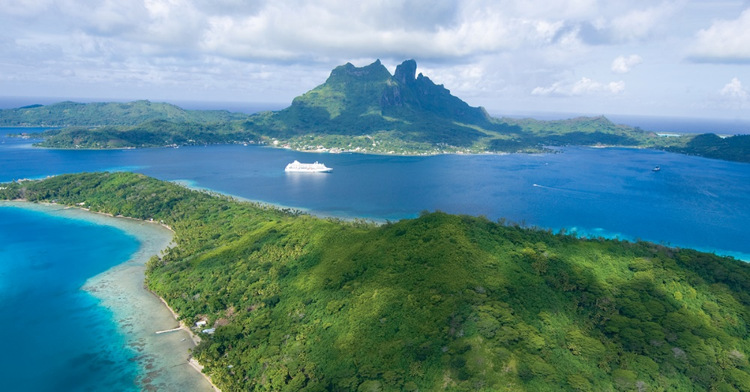

______________________________________________________________________

**Post 2: Distinctive Voyages – Host promoting their assigned voyage**

**FACEBOOK COPY:**

Let’s rediscover the joys of cruising together! Please join me for an exception cruise experience as I am hosting one our outstanding Distinctive Voyages! Please join me on XX Cruise Line departing xxxx city on xxx date as we enjoy a xxxx name of itinerary. As an added bonus you will be invited to a **Private Welcome Reception** and take you on an **Exclusive Shore Event**, all with our compliments! Contact me to learn more. **#DistinctiveVoyages**

**TWITTER COPY:**

Let’s rediscover the joys of cruising together! Please join me for an exception cruise experience as I am hosting one our outstanding Distinctive Voyages! You will also be invited to a **Private Welcome Reception** and experience an **Exclusive Shore Event**, contact me to learn more. **#DistinctiveVoyages**

**INSTAGRAM COPY:**

Let’s rediscover the joys of cruising together! Please join me for an exception cruise experience as I am hosting one our outstanding Distinctive Voyages! Please join me on XX Cruise Line departing xxxx city on xxx date as we enjoy a xxxx name of itinerary. As an added bonus you will be invited to a **Private Welcome Reception** and take you on an **Exclusive Shore Event**, all with our compliments! Contact me to learn more. **#DistinctiveVoyages**

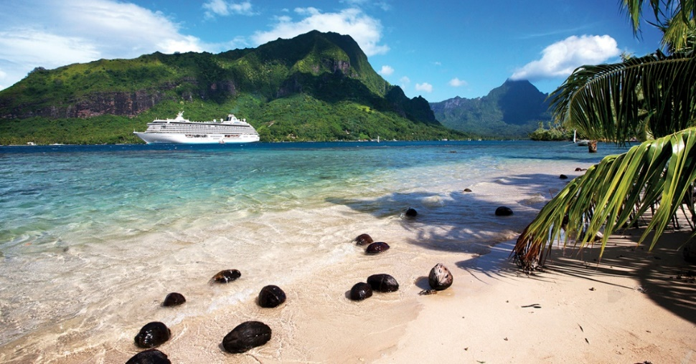

**Distinctive Voyages, Alaska**

**FACEBOOK COPY**

Perfect for adventurers and armchair enthusiasts alike, there is simply no better way to experience Alaska than with a cruise. With tons of options and exclusive amenities already included, Distinctive Voyages has the perfect Alaskan cruise for you. Join us for a **Private Welcome Reception** so you can meet likeminded VIPs, making your adventure even more special. Contact our agency to get matched with the best cruise line for you!

**TWITTER COPY**

Perfect for adventurers and armchair enthusiasts alike, there is simply no better way to experience Alaska than with a cruise. With tons of options and exclusive amenities already included, Distinctive Voyages has the perfect Alaskan cruise for you. Join us for a **Private** **Welcome Reception** so you can meet likeminded VIPs, making your adventure even more special. Contact our agency to get matched with the best cruise line for you!

#DistinctiveVoyages #AlaskanCruise

**INSTAGRAM COPY:**Perfect for adventurers and armchair enthusiasts alike, there is simply no better way to experience Alaska than with a cruise. With tons of options and exclusive amenities already included, Distinctive Voyages has the perfect Alaskan cruise for you. Join us for a **Private Welcome Reception** so you can meet likeminded VIPs, making your adventure even more special. Contact our agency to get matched with the best cruise line for you!

#DistinctiveVoyages #AlaskanCruise

**Suggested Images**

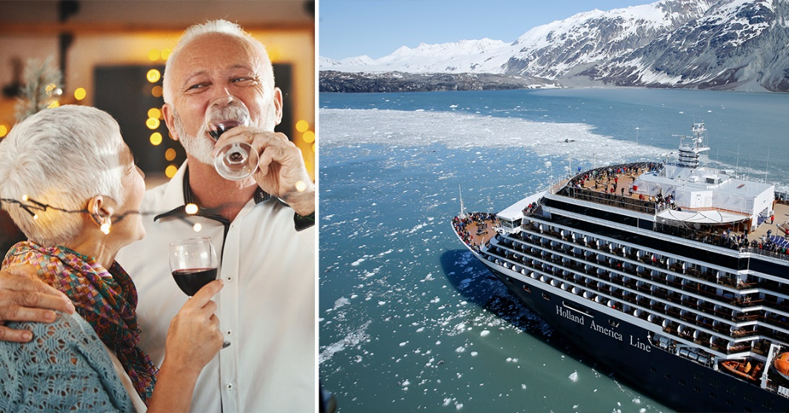

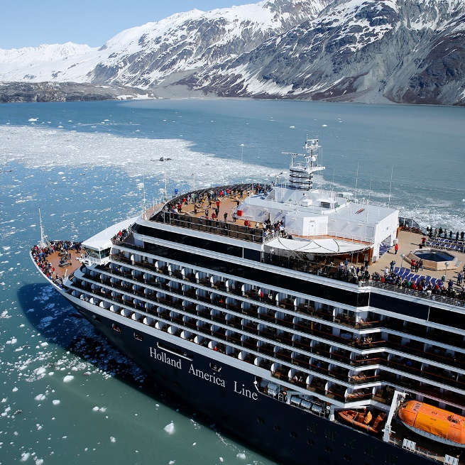

_____________________________________________________________________________

**Post 3 Distinctive Voyages, Luxury, Private Car & Driver**

**FACEBOOK COPY**  
Break away from the crowd and enjoy a personal tour with a private car and driver included with your luxury cruise. This unique amenity is complimentary when you book with our agency. Contact us today! #DistinctiveVoyages #LuxuryCruise

**TWITTER COPY:**   
Break away from the crowd and enjoy a personal tour with a private car and driver included with your luxury cruise. This unique amenity is complimentary when you book with our agency. Contact us today! #DistinctiveVoyages #LuxuryCruise

**INSTAGRAM COPY:**   
Break away from the crowd and enjoy a personal tour with a private car and driver included with your luxury cruise. This unique amenity is complimentary when you book with our agency. Contact us today! #DistinctiveVoyages #LuxuryCruise

**Suggested Images**

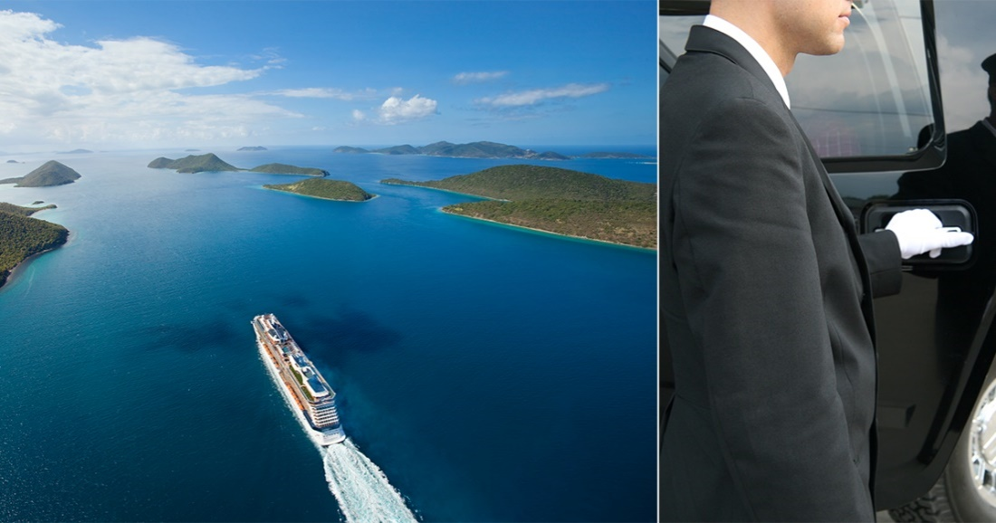

_____________________________________________________________________________

**Post 4**

**FACEBOOK COPY:**Explore popular locations like Sydney and Rome with Distinctive Voyages’ exclusive shore event included with your cruise when you book through us! Contact our travel agency to learn more.  
  
**TWITTER COPY:**Explore popular locations like Sydney and Rome with Distinctive Voyages’ exclusive shore event included with your cruise when you book through us! Contact our travel agency to learn more.

#DistinctiveVoyages #Rome #EuropeanCruise #Sydney #AustraliaCruise  **INSTAGRAM COPY:**   
Explore popular locations like Sydney and Rome with Distinctive Voyages’ exclusive shore event included with your cruise when you book through us! Contact our travel agency to learn more.

#DistinctiveVoyages #Rome #EuropeanCruise #Sydney #AustraliaCruise  
  
IMAGES: 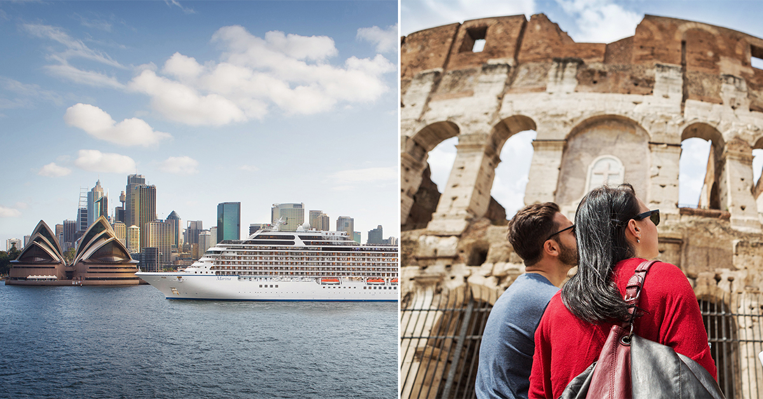

____________________________________________________________________________________

**Post 5: Distinctive Voyages**

**FACEBOOK COPY**

With Distinctive Voyages, you won’t be sailing solo because our onboard hosts have the answer. Just one more perk of booking a Distinctive Voyages sailing through our agency. Contact us today to learn more! #DistinctiveVoyages

**TWITTER COPY**

With Distinctive Voyages, you won’t be sailing solo because our onboard hosts have the answer. Just one more perk of booking a Distinctive Voyages sailing through our agency. Contact us today to learn more! #DistinctiveVoyages

**INSTAGRAM**

With Distinctive Voyages, you won’t be sailing solo because our onboard hosts have the answer. Just one more perk of booking a Distinctive Voyages sailing through our agency. Contact us today to learn more! #DistinctiveVoyages

**Images**

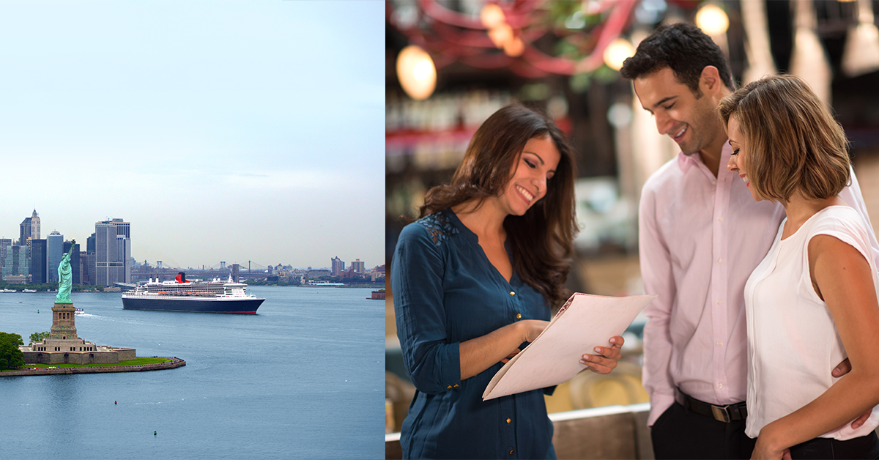

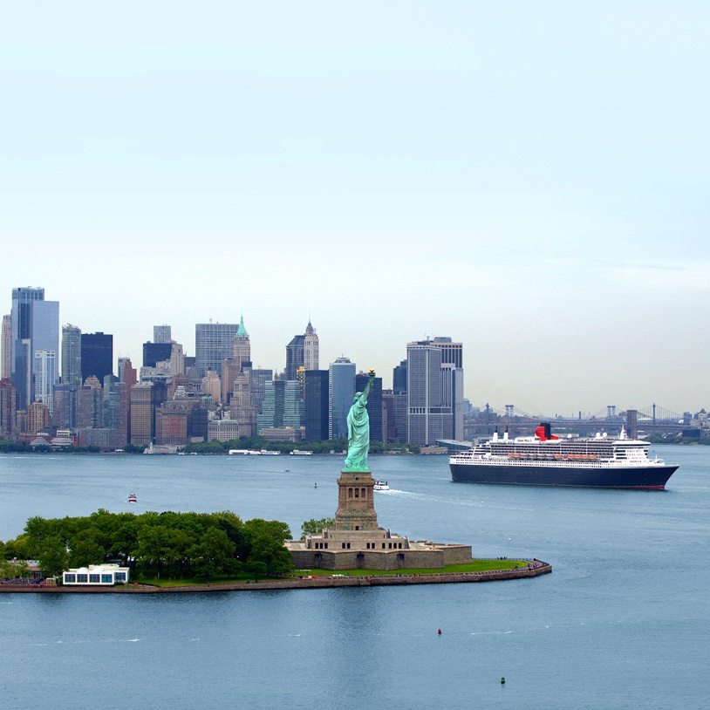

**Post 6: Distinctive Voyages**

**FACEBOOK COPY:**Join me on a Distinctive Voyages sailing! As an added bonus our agency will treat you to a **Private Welcome** **Reception** and take you on an **Exclusive Shore Event**, all complimentary! Contact me to learn more.

**TWITTER COPY:**   
Join me on a Distinctive Voyages sailing! As an added bonus our agency will treat you to a Private Welcome Reception and take you on an Exclusive Shore Event, all complimentary! Contact me to learn more.

#DistinctiveVoyages

**INSTAGRAM COPY:**   
Join me on a Distinctive Voyages sailing! As an added bonus our agency will treat you to a Private Welcome Reception and take you on an Exclusive Shore Event, all complimentary! Contact me to learn more.

#DistinctiveVoyages

**Distinctive Voyages Video:**

1. Download the video from Agent Universe
2. Go to create a post. If you’re using Facebook, select the photo/video option to upload the video: Graphical user interface, text, application, chat or text message

   Description automatically generated
3. Write the post (see suggested copy below)
4. Post!

**Suggested copy:**

Check out all these exclusive benefits! Available on over 350 voyages annually across 13 cruise lines. When you book your cruise with me, these exclusive amenities are my gift to you!